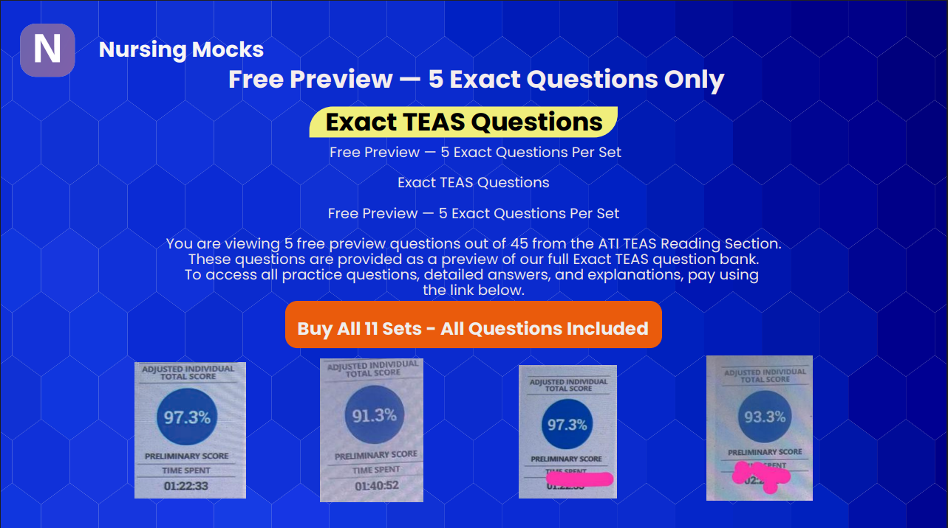

📘 READING

Question 1
Passage:
To achieve this, it is most effective to use something with protein or fat that will bind to the starch. One option is a quarter cup of plain yogurt, sour cream, or buttermilk for each egg—either dairy or non-dairy will work just fine. Another option is ground flax or chia seeds. For each egg, combine 1 tablespoon of ground seeds with 3 tablespoons of warm water and leave the mixture to rest at room temperature for about 10 minutes before using.
Either of these options will effectively bind your ingredients. However, if you are baking something that needs to rise, like a cake, you may want to give your dessert a little additional help. In this case, mix 1 teaspoon of baking soda with 1 tablespoon of a neutral-flavored vinegar, such as white or apple cider, and add this mixture alongside the other wet ingredients.
Question:
Which of the following is a relevant idea needed for an objective summary of this text?
Options:
A. Emulsification is one of the most difficult cooking tasks
B. Egg substitutes should bind and leaven ingredients
C. Nondairy items do not work well
D. Eggs are required
Correct Answer:
B. Egg substitutes should bind and leaven ingredients

Question 2
Passage: (same passage above)
Question:
Which statement identifies the author's point of view?
Options:
A. Applesauce works best
B. Egg substitutes are inferior
C. Chia seeds are best
D. There are many egg substitutes
Correct Answer:
D. There are many egg substitutes

Question 3
Passage: (same passage above)
Question:
Which evidence reinforces that egg substitutions are plentiful?
Options:
A. Bananas provide moisture
B. Leavening is difficult
C. There are dairy and nondairy options
D. Emulsification ruins recipes
Correct Answer:
C. There are dairy and nondairy options

Question 4
Passage: (same passage above)
Question:
Which statement is false or misleading?
Options:
A. Substitutes can be vegan or dairy
B. People with allergies can enjoy recipes
C. Fat is not needed to bind
D. Substitutes must emulsify
Correct Answer:
C. Fat is not needed to bind

Question 5
Passage:
Sales Associate Position (Button Land job description…)
Question:
Which conclusion is true?
Options:
A. Experience required
B. Must like buttons and zippers
C. No weekend work
D. Must have open availability
Correct Answer:
D. Must have open availability

Question 6
Passage: (same job posting)
Question:
What type of job is this?
Options:
A. Management
B. Driving job
C. Temporary
D. Entry-level
Correct Answer:
D. Entry-level

Question 7
Passage:
Butterbean for Mayor (dog campaign satire)
Question:
What is the purpose?
Options:
A. Instruct voting
B. Argue dog eligibility
C. Entertain
D. Inform about pets
Correct Answer:
C. Entertain

Question 8
Passage: (same Butterbean passage)
Question:
What would make it more persuasive?
Options:
A. Proof dogs were elected
B. Vet data
C. Evidence of rat problem
D. Graph on dog popularity
Correct Answer:
C. Evidence of rat problem

Question 9
Passage:
An Ode to Naps (poem…)
Question:
Which words help an illustrator?
Options:
A. Shroud, nest
B. Aura, roof
C. Footsteps, enticing
D. Dance, tempted
Correct Answer:
A. Shroud, nest

Question 10
Passage: (same poem)
Question:
Effect of word choice?
Options:
A. Threatening tone
B. Rhyming for lyrical effect
C. Contrast words
D. Negative tone
Correct Answer:
B. Rhyming for lyrical effect

📊 MATH

Question
Question:
Down payment $400, total $1570 → months at $100
Options:
A. 11
B. 15
C. 16
D. 12
Correct Answer:
D. 12

Question
Question:
Soccer field 100m × 75m → hectares
Options:
A. 0.75
B. 7,500
C. 75,000,000
D. 7.5
Correct Answer:
A. 0.75

Question
Question:
31% of 426
Options:
A. 425.69
B. 132.06
C. 0.07
D. 13.7
Correct Answer:
B. 132.06

Question
Question:
Pizza sharing (½ eaten, rest split by 3)
Options:
A. 1/3
B. 1/6
C. 1/5
D. 1/4
Correct Answer:
B. 1/6

🔬 SCIENCE

Question
Question:
Human hereditary info
Options:
A. Plasmids
B. Chromatin
C. ATP
D. Histones
Correct Answer:
B. Chromatin

Question
Question:
Gas exchange structure
Options:
A. Alveoli
B. Bronchi
C. Trachea
D. Bronchioles
Correct Answer:
A. Alveoli

Question
Question:
Noninfectious disease
Options:
A. Chikungunya
B. Psoriasis
C. Brucellosis
D. Dengue
Correct Answer:
B. Psoriasis

Question
Question:
Site of intracellular digestion
Options:
A. Lysosomes
B. Centrosomes
C. Ribosomes
D. Mitochondria
Correct Answer:
A. Lysosomes

✍️ ENGLISH

Question
Question:
When is informal language appropriate?
Options:
A. Academic journal
B. Email professor
C. Text message
D. Job application
Correct Answer:
C. Text message

Question
Question:
Correct spelling
Options:
A. Hieght
B. Foriegn
C. Receive
D. Vien
Correct Answer:
C. Receive

Question
Question:
Subject of sentence
Options:
A. tree
B. sat
C. under
D. Taylor
Correct Answer:
D. Taylor

Question
Question:
Adverb
Options:
A. swiftly
B. tall
C. across
D. athletic
Correct Answer:
A. swiftly

